**MACHINE CALIBRATION**

The purpose of the calibration routines is to align the programmed part zero to the centerline of both rotary axes. This procedure is typically required if the machine has been subject to some sort of machine collision, electrical power issue or deletion of current calibration data. If you notice your machined units are too thick or too thin or there is a noticeable shift in geometry between the top and the bottom, then a machine calibration is necessary. Aside from something catastrophic occurring, it’s always a good idea to re-calibrate the equipment about every 6 months to ensure that you’re getting the high possible quality out of your 5X-200 mill.

There are 3 programs that are executed to calibrate the machine.

• Y-CALIBRATION.NC – This program determines the center of rotation for the A axis. It machines the part in the Y axis from both sides (A0 and A180) To determine the Y offset.

• Z-B-CALIBRATIPON.NC – This program determines the B and Z offsets by cutting to a known dimension in the Z axis on both sides of the part

• CALIBRATION-ADJUSTMENT.NC – This program is used to make the adjustments to the offsets based upon the calibration measurements entered this program. All calculations and register updates are performed automatically.

Load the calibration block into the fixture as shown. Mark the top, bottom and center face surfaces with a marker. This helps you to see if the tool has cut all the way across the surface.

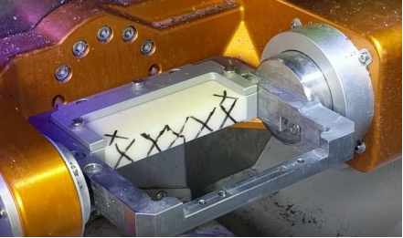

**Y AXIS CALIBRATION**

There are 2 pieces of information you’ll need to know to run the calibration programs:

• Approximate distance from the center of the fixture to the face of the block

• The thickness you want to cut on the puck

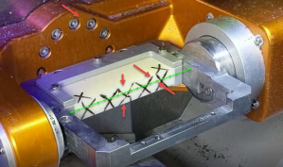

**EDIT THE Y-CALIBRATION.NC PROGRAM**

; Y-AXIS CALIBRATION

; ENTER THE PUCK THICKNESS INTO #1

; ENTER THE Y POSITION YOU WANT TO CUT - TOOL DIAMTER IS ACCOUNTED FOR

#1=16.2 ; PUCK THICKNESS

#2=8.5; Y DISTANCE FROM CENTER

First, set the Value for #1 to the desired thickness you want to cut. This value should be about .2mm less than its current thickness. Set #2 to the distance from Centerline you want to cut. For a new short block this value should be around 8.0. Save the program and open it in the control to run.

The tool will cut halfway down at the A0 position and then other half from the A180 position. Make sure the cut has removed the material all the way across the face. If not, then adjust #2 to cut a little deeper.

The left image below shows cutting at A0. The middle image below shows cutting at A180. The right image below shows the cut after completion of the NC program.

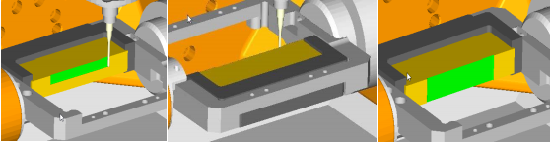

**MEASURING THE Y AXIS**

Use the dial indicator to determine the values for the Y axis calibration. Use the Jog panel to move the indicator to the upper left position and touch the needle to the part. Record the value on the dial or rotate the dial to zero. Jog X+ to the next position this should measure the same as the previous positions.

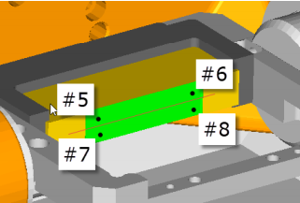

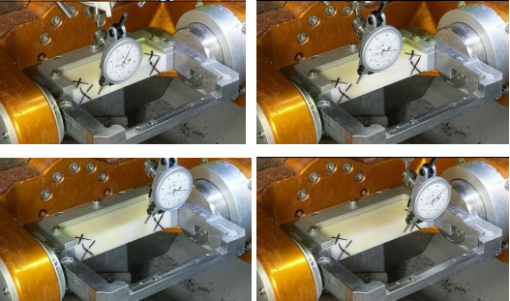

When reading the indicator in this position the needle moved in the counter clockwise direction from the 0 mark. This indicates a positive value.

**Z AND B AXIS CALIBRATION**

Next edit the Z-B-CALIBRATION.NC program.

This program cuts 2 small circular pads on each end of the block on both the top and bottom.

; Z AND B CALIBRATION

#1=15.5 ;CUT THICKNESS

#2=8.3 ; STARTING Y POSITION

The value for #1 is the desired thickness to be cut.

The Value for # 2 is the distance from centerline of A to the center of the pad Cutting the A0 sideCutting the A180 Side

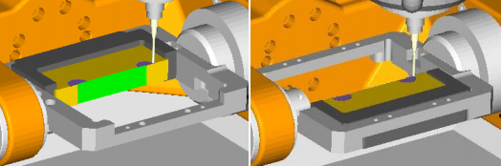

**MEAUSRING THE Z AND B AXIS**

Once both calibration programs have been run then it’s time to measure and record the results. Use the digital micrometers to measure the thickness at the left and right circular pads. Make sure the Micrometers are set to mm. This will determine the values needed to set the Z and B work offsets

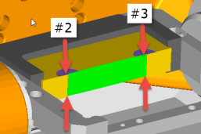

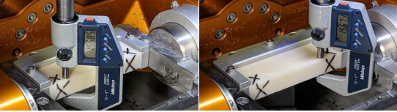

**ADJUSTING THE WORK OFFSETS**

The final step is to edit the calibration adjustment program (CALIBRATION-ADJUSTMENT.NC). You’ll enter the values you measured previously into assigned register in the program. The program then calculates the adjustments needed to the Z, Y and B axes for the G55 work offset and then automatically updates the necessary registers in the control.

Start by entering the programmed Z value thickness that you entered in the Z-B-CALIBRATION.NC program in the #1 register.

Next, enter the values you measured using the micrometers. Make sure you enter the left and right values correctly. Switching the left and right values will modify the B axis rotary adjustment in the wrong direction.

Next, enter the indicator values in the corresponding registers. NOTE that most indicators used are in the inch unit. The program automatically adjusts for this conversion. If you are using a metric indicator, you will need to convert those values to inches to use this program. If you do have a metric indicator, please contact Axsys Dental solutions to get a metric indicator version of the program.

; CALIBRATION ADJUSTMENT PROGRAM

; ADJUSTS Z,B,Y VALUES FOR G55

; #2387_Y #2388_Z #2390_B

#1=15.7 ;PROGRAMMED Z THICKNESS IN MM

#2=15.685 ;LEFT SIDE MEASUREMENT IN MM

#3=15.673 ;RIGHT SIDE MEASUREMENT IN MM

#4=60 ;DISTANCE BETWEEN MEASUREMENTS IN MM

#5=0.0000 ;UPPER LEFT IN INCHES

#6=0.0000 ;UPPER RIGHT IN INCHES

#7=0.0015 ;LOWER LEFT IN INCHES

#8=0.0010 ;LOWER RIGHT IN INCHES

Once the data has been entered, save the file and load it into memory. Press start to run the program. NOTE: There is no motion that will occur, it’s just doing math. There’s a dwell of 5 seconds in the program to make the start light flash once. This is your only indication that the program has run. DO **NOT** press the start button a second time. **Doing so will double the offset amount calculated and you’ll need to start all over again.**